Musculoskeletal Test Revision

Describe how a muscle contracts and including the energy process that happens
______________________________________________________________________________________
______________________________________________________________________________________
______________________________________________________________________________________

Describe the joint types in the vertebrae
______________________________________________________________________________________
______________________________________________________________________________________

Describe how muscles for movement must work together
______________________________________________________________________________________
______________________________________________________________________________________

Compare and contrast adduction and abduction
______________________________________________________________________________________
______________________________________________________________________________________
______________________________________________________________________________________
______________________________________________________________________________________

Describe the following joints
gliding joint _____________________________________________________________________________
pivot joint ______________________________________________________________________________
hinge joint ______________________________________________________________________________
ball and socket joint ______________________________________________________________________

What bones make up the axial skeleton? ______________________________________________________
What bones make up the appendicular skeleton? _______________________________________________

Describe the following bones
scapula ________________________________________________________________________________
sternum ________________________________________________________________________________
pelvis __________________________________________________________________________________
sacrum _________________________________________________________________________________

Describe the sliding filament model of muscle contraction
_______________________________________________________________________________________

Compare and contrast the bones in the fingers and the toes
______________________________________________________________________________________
______________________________________________________________________________________

Describe
epiphysis _______________________________________________________________________________
diaphysis _______________________________________________________________________________

Describe how the quadriceps and hamstrings work together
______________________________________________________________________________________
______________________________________________________________________________________

In skeletal muscle contraction, the role of calcium ions is very important. Name the internal cellular structure that stores calcium ______________________________________________________________

Describe how the three different types of muscle would look under a microscope
______________________________________________________________________________________
______________________________________________________________________________________
______________________________________________________________________________________
______________________________________________________________________________________

What distinguishes muscle tissue from all other tissue in the body?
______________________________________________________________________________________
______________________________________________________________________________________

What are thick myofilaments made of? ______________________________________________________

Describe the three different types of cartilage
______________________________________________________________________________________
______________________________________________________________________________________
______________________________________________________________________________________

A muscle is made up of bundles of these structures held together by connective tissue ________________

What bones make up the shoulder girdle (or pectoral girdle)
______________________________________________________________________________________

What are joints that don’t move called, what are joints that do move called
______________________________________________________________________________________

Be able to label a long bone, smooth bone and a flat bone. Include the following parts: diaphysis, epiphysis, marrow cavity, articular cartilages, compact bone, spongy bone, bone marrow and periosteum.

Described the movement and location of synovial joints
______________________________________________________________________________________
______________________________________________________________________________________
______________________________________________________________________________________
______________________________________________________________________________________
______________________________________________________________________________________
______________________________________________________________________________________

Name the five main functions of the skeleton. Give an example which illustrates each function.
Functions of the skeleton | Example

Label the attachments marked A to F on the diagram below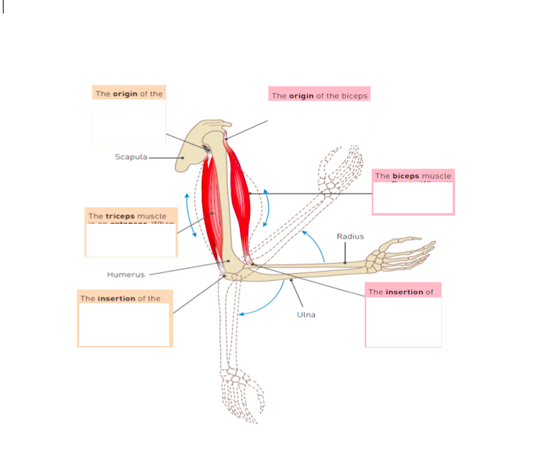

This is a representation of a muscle unit
What happens at
S ___________________________________________________________________________________
A ___________________________________________________________________________________
H ___________________________________________________________________________________
M ___________________________________________________________________________________
I ____________________________________________________________________________________
What happens at A when the muscle contracts? ______________________________________________

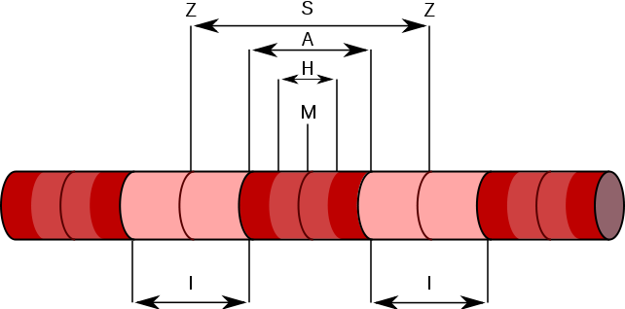

The irregular lines on the skull indicate where different bones join. What is the name given to this type of joint found in the skull? _________________________________________________________________

Bone is what type of tissue? What other parts of the body are this type of tissue? ____________________
_______________________________________________________________________________________

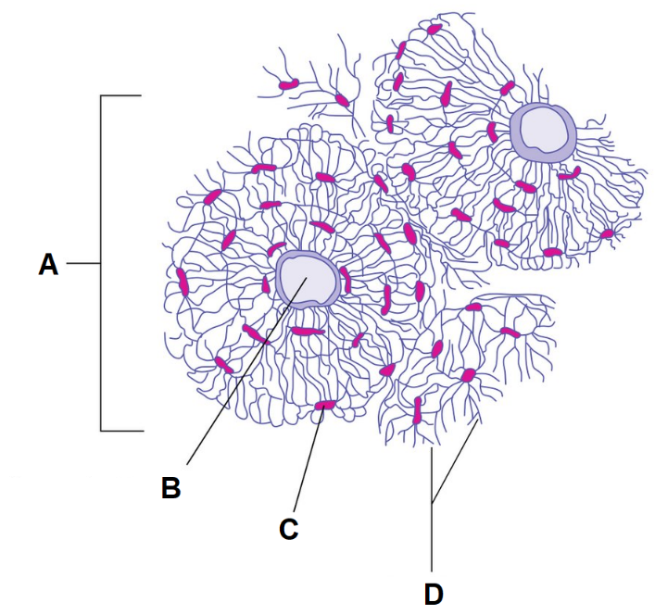
Label each part of this Illustration of bone

A ________________________________
B ________________________________
C ________________________________
D ________________________________

Calcium is deposited by bone cells along
with collagen to give bone its stiffness.
Where does this deposition occurs?

It is often said that a broken bone is better than a tear in cartilage. Discuss why bone heals faster than a tear in cartilage. _______________________________________________________________________
_______________________________________________________________________________________
_______________________________________________________________________________________

Describe the differences in structure between compact and spongy bone.
_______________________________________________________________________________________
_______________________________________________________________________________________
_______________________________________________________________________________________
_______________________________________________________________________________________

What type of joint is the knee joint? ________________________________

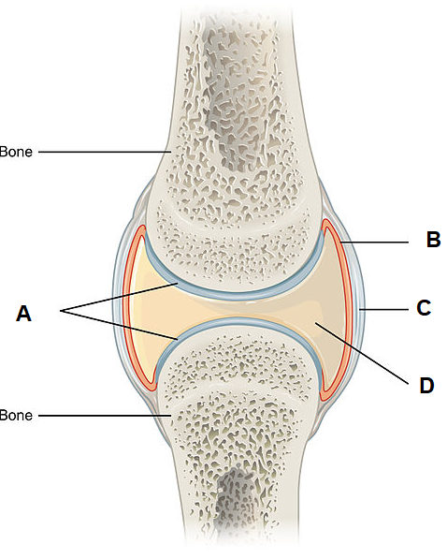
Name the structures at
A __________________________________
B __________________________________
C __________________________________
D __________________________________

Describe how the structures labelled B and D prevent injury to these types of joints.

